**Students / Faculty requesting Microsoft Office 365.**

Sign in at https://www.office.com/ with your KVCC email address: username@mail.kvcc.edu and then your MyValley password. After the 2-factor authentication, you can download Office 365 on your device.

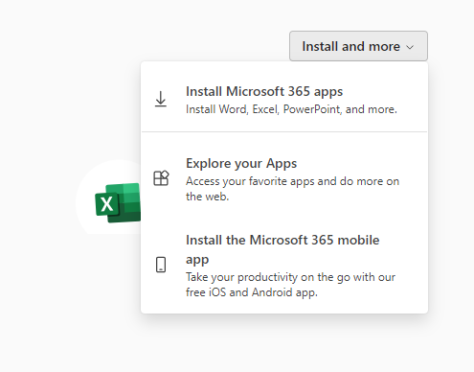Click on the “Install and More” drop down menu in the top right, then click Install Microsoft 365 Apps.

Click on the Install Office button on the next page that shows up. When the download finishes, run the installer.

Once it is done, open any office app such as Word and sign in using your KVCC e-mail.

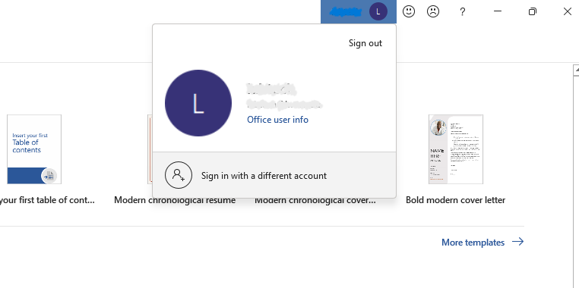Alternatively, if you already have Microsoft Office installed, just sign in with your KVCC e-mail at the top of the application.